***Project Report***

***On­­­***

**Hand Gesture and Recognition**

Submitted in partial fulfilment of the requirement for the award for the degree of

**BACHELOR OF ENGINEERING**

**IN**

**COMPUTER SCIENCE & ENGINEERING**



**Submitted by: Submitted to:**

**Rahul Kumar(17bcs1548) Ms. Navjot Kaur**

**Harshit Walia(17bcs1621)**

**DEPARTMENT OF COMPUTER SCIENCE & ENGINEERING**

**CHANDIGARH UNIVERSITY, GHARUAN**

**Nov 2019**

### CERTIFICATE

This is to certify that the work embodied in this Project Report entitled **“ HAND GESTURE AND RECOGNITION”** being submitted by **“RAHUL KUMAR(17BCS1548) and HARSHIT WALIA(17BCS1621) ”** in 5th Semester for partial fulfillment of the requirement for the degree of **“ Bachelor of Engineering in Computer Science & Engineering ”** discipline in “ **Chandigarh University** ” during the academic session July-Dec 2019 is a record of bona fide piece of work, carried out by student under my supervision and guidance in the **“ Department of Computer Science & Engineering ”, Chandigarh University.**

**Approved & Guided by:**

Ms. Navjot Kaur

Assistant professor (CSE Dept.)

### DECLARATION

### I, student of Bachelor of Engineering in Computer Science & Engineering, 5th Semester , session: July – Dec 2019, Chandigarh University, hereby declare that the work presented in this Project Report entitled “HAND GESTURE AND RECOGNITION ” is the outcome of my own work, is bona fide and correct to the best of my knowledge and this work has been carried out taking care of Engineering Ethics. The work presented does not infringe any patented work and has not been submitted to any other university or anywhere else for the award of any degree or any professional diploma.

**Student details and Signature**

Rahul Kumar(17BCS1548)

Harshit Walia(17BCS1621)

**Approved & Guided by:**

Ms. Navjot Kaur

Assistant professor (CSE Dept.)

**ACKNOWLEDGEMENT**

**RAHUL KUMAR**

**HARSHIT WALIA**

We avail this opportunity to offer our sincere thanks and deep sense of gratitude to our project coordinator and guide Prof. Navjot Kaur, Department of Computer Science and engineering, Chandigarh University, Mohali. His Constance inspiration and dynamic guidance has helped us a lot to complete and materialized our project work.

The project development requires huge commitments from individuals involved in it. We would also like to acknowledge all the staff for providing a helping hand to us in the time to us in the time of queries and problems,

Lastly we would like to thank all our friends and peers for their suggestion and kind help.

**ABSTRACT**

The objective of the project **‘Hand Gesture and Recognition’** is to develop a system that can be used for interfacing between computer and human using hand gesture. This work presents a technique for a human computer interface through hand gesture recognition that is able to recognize the user hand gesture. The objective of this project is to develop an algorithm for recognition of hand gestures with reasonable accuracy. In which we wish to make a windows-based application for live motion gesture recognition using webcam and open cv library. This project is a combination of live motion detection and gesture identification. This application uses the webcam to detect gesture made by the user and perform basic operations accordingly. The user has to perform a particular gesture. The webcam captures this and identifies the gesture, recognizes it (against a set of known gestures) and performs the action corresponding to it.

**TABLE OF CONTENT**

|  |  |  |
| --- | --- | --- |
| S.NO. | TOPIC | PAGE NO. |
| 1 | Introduction | 8,9 |
| 2 | Software requirement specification | 10 |
| 3 | System Requirements | 11 |
| 4 | System Design  4.1 Flow Diagram  4.2 Use case Diagram | 12,13 |
| 5 | System Analysis  5.1 Defining a problem  5.2 Feasibility Study  5.3 System Study | 14-17 |
| 6 | Project Methodology  6.1 Different phases of hand gesture recognition | 18,19 |
| 7 | Testing  7.1 Testing Phase  7.2 Levels of Testing  7.3 Code Testing  7.4 Specification Testing | 20-22 |
| 8 | Result | 23-26 |
| 9 | Conclusion and future scope | 27-28 |
| 10 | References | 29 |

**LIST OF FIGURES**

|  |  |  |
| --- | --- | --- |
| **S.NO.** | **TITLE** | **FIG.NO.** |
| 1 | Flow Diagram | Fig.1 |
| 2 | Use case Diagram | Fig.2 |
| 3 | Phases of hand gesture recognition | Fig.3 |
| 4 | Levels of Testing | Fig.4 |
| 5 | Screenshot | Fig(5-20) |

**INTRODUCTION**

In which we wish to make a windows-based application for live motion gesture recognition using webcam and open cv library. This project is a combination of live motion detection and gesture identification. This application uses the webcam to detect gesture made by the user and perform basic operations accordingly. The user has to perform a particular gesture. The webcam captures this and identifies the gesture, recognizes it (against a set of known gestures) and performs the action corresponding to it.In which we are using python language.

As we know, the vision-based technology of hand gesture recognition is an important part of human-computer interaction (HCI). In the last decades, keyboard and mouse play a significant role in human-computer interaction. However, owing to the rapid development of hardware and software, new types of HCI methods have been required. In particular, technologies such as speech recognition and gesture recognition receive great attention in the field of HCI.

Gesture is a symbol of physical behavior or emotional expression. It includes body gesture and hand gesture. It falls into two categories: static gesture and dynamic gesture. For the former, the posture of the body or the gesture of the hand denotes a sign. For the latter, the movement of the body or the hand conveys some messages. Gesture can be used as a tool of communication between computer and human. It is greatly different from the traditional hardware based methods and can accomplish human-computer interaction through gesture recognition. Gesture recognition determines the user intent through the recognition of the gesture or movement of the body or body parts. In the past decades, many researchers have strived to improve the hand gesture recognition technology. Hand gesture recognition has great value in many applications such as sign language recognition, augmented reality (virtual reality), sign language interpreters for the disabled, and robot control.

In this the authors detect the hand region from input images and then track and analyze the moving path to recognize America sign language. Zeng et al.improve the medical service through the hand gesture recognition. The HCI recognition system of the intelligent wheelchair includes five hand gestures and three compound states. Their system performs reliably in the environment of indoor and outdoor and in the condition of lighting change.

The work flow of hand gesture recognition described as follows. First, the hand region is detected from the original images from the input devices. Then, some kinds of features are extracted to describe hand gestures. Last, the recognition of hand gestures is accomplished by measuring the similarity of the feature data. The input devices providing the original image information includes normal camera, stereo camera, and ToF (time of flight) camera. The stereo camera and ToF camera additionally provide the depth information so it is easy to segment the hand region from the background in terms of the depth map. For the normal camera, the skin color sensitive to the lighting condition and feature points are combined to robustly detect and segment the hand region. When the region of interest (ROI, the hand region in the case) is detected, features are needed to be extracted from the ROI region. Color, brightness, and gradient values are widely used features. For the recognition of hand gestures, various classifiers, for example, SVM (support vector machine), HMM (hidden Markov model), CRF (conditional random field), and adapted boosting classifier are trained to discriminate hand gestures. Although the recognition performance of these sophisticated classifiers is good, the time cost is very high.

In this paper, we present an efficient and effective method for hand gesture recognition. The hand region is detected through the background subtraction method. After the fingers are recognized, the hand gesture can be classified through a simple rule classifier.

The novelty of the proposed method is listed as follows.

(i)The first novelty of the proposed method is that the hand gesture recognition is based on the result of finger recognition. Our approach only uses a normal camera to capture the vision information of the hand gesture meanwhile does not need the help of the special tape to detect hand regions.

(ii)The second advantage of the proposed method is that it is highly efficient and fit for real-time applications.

**SOFTWARE REQUIREMENT SPECIFICATION**

The purpose of the Software requirement specification (SRS) is to describe the external behaviour of the software. Requirement specification describes and defines the operation, interfaces, performances and quality assurance requirements. The documents also describe non functional requirements such as user hardware and software. It also describe the design constraints that are to be considered as when the system is to be designed, and other factor necessary to provide a complete and comprehensive description and requirement for the software. Thus the SRS captures the complete software requirement for the system.

**PERFORMANCE REQUIREMENTS**

Performance is measured in terms of the output provided by the application. Requirement specification plays an important part in the analysis of a system. Only when the requirement specification are properly given, it is possible to design a system, which will fit into required environment. It rests largely with the users of the existing system to give the requirement specifications because they are the people who finally use the system .This is because the requirements have to be known during the initial stages so that the system can be designed according to those requirements. It is very difficult to change the system once it has been designed and on the other hand designing a system, which does not cater to the requirements of the user, is of no use. The requirement specification for any system can be broadly stated as given below:

* The system should be able to interface with existing system.
* The system should be accurate.
* The system should be better than existing system. The existing system is completely

dependent on the user to perform all duties.

**SYSTEM REQUIREMENT**

1. **Software requirement:**

* Opencv.
* Spyder.
* OPERATING SYSTEM: Window 8 or newer version.
* LANGUAGE: Python.

1. **Hardware requirement:**

* Web camera.
* Ram 2 GB.
* 512 KB Cache memory.
* Laptop or Pc with i3 processor.

**SYSTEM DESIGN**

System design is the process or art of defining the architecture, components, modules, interfaces, and data for a system to satisfy specified requirements. One could see it as the application of system theory to product development. There is some overlap and synergy with the disciplines of systems analysis, systems architecture and systems engineering.

**FLOW DIAGRAM:**

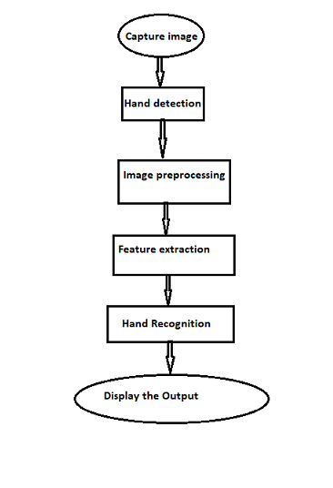

**Fig.1**

**USE CASE DIAGRAM:**

In this unified Modeling Language (UML), a case diagram can summarize the details of your system’s users (also known as actors) and their interactions with the system.

* Scenarios in which your system or application interacts with people, organizations, or external systems.
* Goals that your system or application helps those entities (known as actor) achieve.

**Hand gesture use case diagram (fig. 2)**

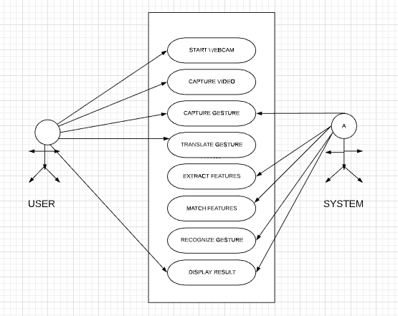

**SYSTEM ANALYSIS**

System analysis is the process of gathering and interpreting facts, diagnosing problems and the information to recommended improvements on the system. System analysis is a problem solving activity that requires intensive communication between the system users and system developers. System analysis or study is an important phase of any system development process. The system is studied to the minutes detail and analyzed. The system analyst plays the role of interrogator and dwells deep into the working of the present system. The system is viewed as qa whole and the input to the system are identified. The outputs from the organizations are to the various processes.

A detailed study of the process must be by various techniques like interviews, questionnaires etc. The data collected by these sources must be scrutinized to arrive to a conclusion. The conclusion is an understanding of how the system functions. This system is called existing system. Now the existing system is subjected to close study and problem areas are identified. The designer now functions as a problem solver and tries to sort out difficulties that the enterprises faces. The solution are given proposals. The proposal is then weighed with the existing system analytically and the best one is selected. The proposal is presented to the user for an endorsement by the user. The proposal is reviewed on user request and suitable changes are made. This is loop that ends as soon as the user is satisfied with proposal.

The way that is followed while carrying on with the development application is as follow:

**DEFINING A PROBLEM**

Defining a problem is one of the important activities of the project. The objective is to define precisely the business problem to be solved and thereby determined the scope of the new system. This phase consists of 2 main tasks. The 1st task within this activity to review the organization needs that originally initiated the project. The 2nd task is to identify, at an abstract or general level, the expected capabilities of the new system. Thus, it helps us to define the goal to be achieved and the boundary of the system. A clear understanding of the problem will help us in building a better system and reduce the risk of project failure. It also specifies the resources that have to be made available to the project. Three important factors project goal, project bound, and the resources limits are sometimes called the projects term reference,

**FEASIBILITY STUDY**

A project feasibility study is a comprehensive report that examines in detail the five frames of analysis of a given project. It also takes into consideration its four Ps, its risks and POVs, and its constraints (calendar, costs, and norms of quality). The goal is to determine whether the project should go ahead, be redesigned, or else abandoned altogether.[[5]](https://en.wikipedia.org/wiki/Feasibility_study#cite_note-5). The five frames of analysis are: The frame of definition; the frame of contextual risks; the frame of potentiality; the parametric frame; the frame of dominant and contingency strategies.

The four Ps are traditionally defined as Plan, Processes, People, and Power. The risks are considered to be external to the project (e.g., weather conditions) and are divided in eight categories: (Plan) financial and organizational (e.g., government structure for a private project); (Processes) environmental and technological; (People) marketing and sociocultural; and (Power) legal and political. POVs are Points of Vulnerability: they differ from risks in the sense that they are internal to the project and can be controlled or else eliminated.

The constraints are the standard constraints of calendar, costs and norms of quality that can each be objectively determined and measured along the entire project lifecycle. Depending on projects, portions of the study may suffice to produce a feasibility study; smaller projects, for example, may not require an exhaustive environmental assessment.

Types of feasibility study are as follows:

There are various measures of feasibility that helps to decide whether a particular project is feasible or not these measures include:

* Economic Feasibility: An evaluation of development cost weighted against the ultimate income or benefits derived from the developed system.
* Technical Feasibility: A study of function, performance and constraints that may affect the ability to achieve an acceptable system.
* Operational Feasibility: A study about the operational aspects of the systems.

**OPERATIONAL FEASIBILITTY**

Operational feasibility is the measure of how well a proposed system solves the problems, and takes advantage of the opportunities identified during scope definition and how it satisfies the requirements identified in the requirements analysis phase of system development.

The operational feasibility assessment focuses on the degree to which the proposed development project fits in with the existing business environment and objectives with regard to development schedule, delivery date, [corporate culture](https://en.wikipedia.org/wiki/Corporate_culture) and existing business processes.

To ensure success, desired operational outcomes must be imparted during design and development. These include such design-dependent parameters as reliability, maintainability, supportability, usability, producibility, disposability, sustainability, affordability and others. These parameters are required to be considered at the early stages of design if desired operational behaviours are to be realised. A system design and development requires appropriate and timely application of engineering and management efforts to meet the previously mentioned parameters. A system may serve its intended purpose most effectively when its technical and operating characteristics are engineered into the design. Therefore, operational feasibility is a critical aspect of systems engineering that needs to be an integral part of the early design phases.

**TECHNICAL FEASIBILITY**

This assessment is based on an outline design of system requirements, to determine whether the company has the technical expertise to handle completion of the project.When writing a feasibility report, the following should be taken to consideration:

* A brief description of the business to assess more possible factors which could affect the study
* The part of the business being examined
* The human and economic factor
* The possible solutions to the problem

At this level, the concern is whether the proposal is both *technically* and [*legally*](https://en.wikipedia.org/wiki/Legally) feasible (assuming moderate cost).

The technical feasibility assessment is focused on gaining an understanding of the present technical resources of the organization and their applicability to the expected needs of the proposed system. It is an evaluation of the hardware and software and how it meets the need of the proposed system.

**ECONOMIC FEASIBILITY**

In making recommendations a study of the economics of the proposed system should be made.

Even though finding out the costs of the proposed project is difficult we assume and estimate the costs and benefits as follows. According to the computerized system we propose, the costs can be broken down into categories.

* Costs associated with the development of the system.
* Costs associated with operating system.

**SYSTEM STUDY**

“System Analysis” describes what a system do to meet the info needs of users while “System Design” specifies how the system will accomplish this objective. This most creative and challenging phase of the system life cycle. The term ‘design’ describes a final system and process by which it is developed. It refers to the technical specifications.

* Describing Activities of System Design.
* System Design is divided into two activities.
* Logical Design Activity.
* Physical Design Activity.
* Both activities produce system Specification satisfying the system.

**Process Design**

The program design activity focus on design of software resources that is programs and procedures needed by proposal system. It concentrates on detailed specification for the program

Modules, that will be purchased as software packages or development by custom programming needed to meet user interface and data specification as well as control and performance requirements for proposed IS.

It must also specify how such resources will convert data resources into info products.

**PROJECT METHODOLOGY**

1. In this project we have to recognize the hand gesture and then count the finger according to the given input and show the sign of ok and best of luck with the help finger as input and display the output according to that. Here is the some method to get output from given input.
2. Aim of the project is to develop a hand gesture recognition program that can recognize the different gesture of hands, The python script detects a object of specified object color from the webcam video feed.
3. Using OpenCV library for Vision tasks and HSV color space for detecting object of given specific color. The role of camera is to capture the image of hand in the frame and then convert the BGR color to HSV coloR .
4. Then cosine formula is used to find the angle between the fingers. The different gestures are differentiated on the basis of the contour and the convex hull area ratio and also on the basis of the angle between the finger of the hand shown inside the frame (if the angle is smaller than ninety degree than it is considered as a defect ) .The number of fingers are equal to the number of defects plus one in it.
5. The goal of this program is to recognize the gesture from the given input stream.

**Different phases of hand gesture recognition: -**

1. **Capture image:**- You can use of web camera to capturing the video frames and it is processing into image.
2. **Hand detection:-** In which we are using of OPENCV library. Through the use of OPENCV library machine can detect that its human hand.
3. **Preprocessing:-**In this phase we process the capture image and define the region of interest converted them into BGR to HSV color and after that define skin color into HSV the upper and lower Range
4. **Feature extraction:-**Using the back substitution method we have to mask the capture image. In which Anything that is your skin color will be taken as 1 or white and anything that is not your skin color will be taken as o or black
5. **Gesture recognition:-**In this phase we have to recognize the hand gesture using cosine formula. In the cosine formula if the angle between the two finger is less than the 90 degree, count that defect and make blue circle over there.
6. **Display the output:**- In the output phase we have to count the finger in the region of interest with the help of defect. It display the output by counting the number of defect plus one.

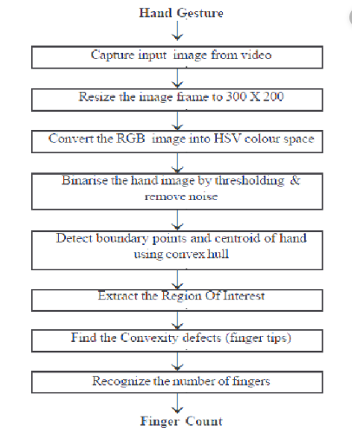

**Fig.3**

**TESTING**

**TESTING PHASE**

The basic goal of the software development process is to produce software that has no error or very few errors. In an effort to detect errors soon after they are introduced, each phase ends with verification activity such as a review.

As testing is the last phase before the final software is delivered, it has the enormous responsibility of detecting any type of error that may in the software. A software typically undergoes changes even after it has been delivered, and to validate that a change has not affected some old functionality of software regression testing performed.

**LEVELS OF TESTING**

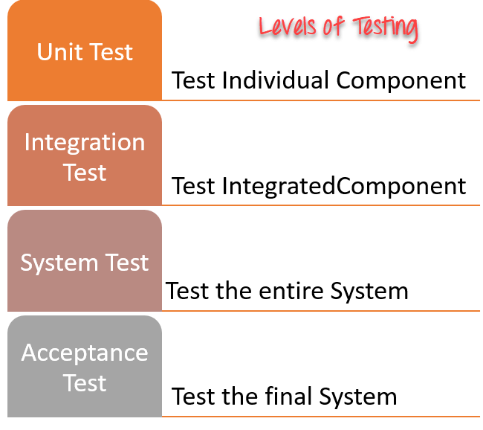

**Fig.4**

**Testing:** The system development lifecycle involves the phases of testing and debugging after the requirement analysis, designing and coding. The project in question was tested, debugged and implemented successfully.

**Two strategies of software testing adopted for the new system are as follow:**

* Code testing
* Specification testing.

**CODE TESTING**

Code testing was carried out to see the correctness of the logic involved and the correctness of the modules. Tests were conducted based upon sample and live data as well. All the module are checked separately for assuming correctness and accuracy in all the calculation.

**SPECIFICATION TESTING**

It examines the specification stating about what program should do and how it perform under various conditions. This testing strategy is better strategy since it focuses on the way the software is expected to work.

**Unit testing:**

During this phase of unit testing different constituent modules were testing against the specification produced during the design for the modules. Unit testing is a [software testing](https://en.wikipedia.org/wiki/Software_testing) method by which individual units of [source code](https://en.wikipedia.org/wiki/Source_code), sets of one or more computer program modules together with associated control data, usage procedures, and operating procedures, are tested to determine whether they are fit for use.

1. **White box testing done**

During this phase of the testing phase SDLC, server developed was tested while considering a valid value corresponding to each of variable defined and corresponding to each function defined. During this phase values corresponding to each variable viz. URL filtering , word filtering and scheduling was done and desired results were obtained.

1. **Black box testing done**

This phase of testing deals with input/output testing. Black box testing was performed on the software development corresponding to valid inputs provided desired outputs were obtained.

**Integration testing:**

Integration testing is the phase in software testing in which individual software modules are combined and tested as a group. Integration testing is conducted to evaluate the compliance of a system or component with specified functional requirements. It occurs after unit testing and before validation testing.

**Functional Testing:**

Functional testing is a quality assurance process and a type of black-box testing that bases its test cases on the specifications of the software component under test. Functions are tested by feeding them input and examining the output, and internal program structure is rarely considered.

**Stress Testing:**

Stress testing (sometimes called torture **testing**) is a form of deliberately intense or thorough **testing** used to determine the stability of a given system or entity. It involves **testing** beyond normal operational capacity, often to a breaking point, in order to observe the results.

**Acceptance Testing:**

Acceptance Testing is a level of software **testing** where a system is tested for acceptability. The purpose of this **test** is to evaluate the system's compliance with the business requirements and assess whether it is acceptable for delivery.

**RESULT**

**Snapshot :-**

**Count of finger :**

1. **Zero:** In which number of defect is null and the output is zero.

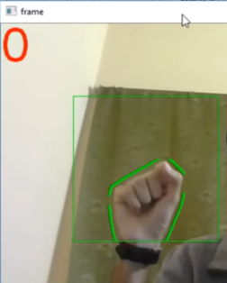 

**Fig.5** **Fig.6**

**2. One:** In which also the number of defect is null and the output is one. It comes under the else condition and its output depends on its area.

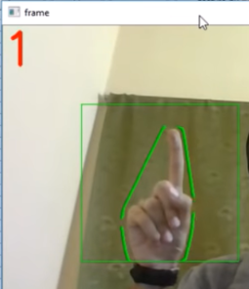 

**Fig.7 Fig.8**

**3. Best of Luck:-** In which number of defect is null and the output is best of luck. It also comes under the else condition and its output depends on its area.

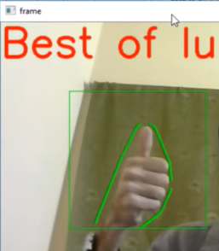 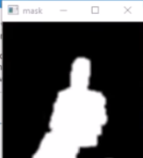

**Fig.9 Fig.10**

**4. Two:** In which number of defect is one and add one so that the output is two.

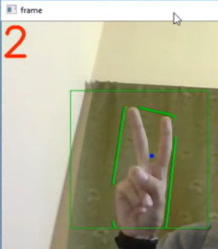 

**Fig.11 Fig.12**

**5. Three:** In which number of defect is two and add one so that the output is three.

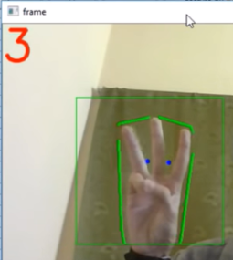 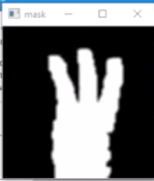

**Fig.13 Fig.14**

**6. Four:** In which number of defect is Three and add one so that the output is four.

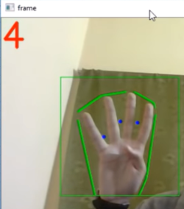 

**Fig.15 Fig.16**

**7. Five:** In which number of defect is four and add one so that the output is five.

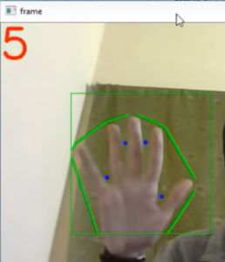 

**Fig.17 Fig.18**

**8.Then ok:** In which number of defect is two and add one so that the output is ok.

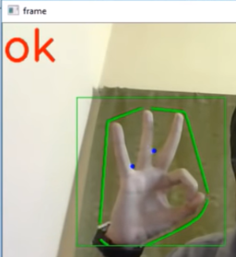 

**Fig.19 Fig.20**

**CONCLUSION AND FUTURE SCOPE**

The system is built to recognize gestures and trigger event based on it. It will recognize the human hand using open CV library. We can count the number of fingers in our hand, best of luck and ok sign according to given input. It convert BGR color into HSV color. This can also be used to set a numeric password for a lock in computer. The result show a significant high accuracy. Currently the system is in two dimensions we also plan to implement in three dimension making depth as the third parameter.

**FUTURE WORK:**

There are some aspects of projects which can be improved in future.

* Instead of webcam a better and more accurate acquisition device can be used which even used infrared for accuracy e.g. kinect.
* Mechanism for hand detection is not accurate.
* HU set of invariant moments are very basic descriptors as features of image which will not have good accuracy. A better descriptor can give good results but classification mechanism may change.
* Add some extra gestures in the system.

**Applications of project:**

As we are moving towards a more immersive computing age, we would be moving away from traditional input devices like Keyboards or Mouses. With the rise of AR and VR, we would see a new breed of interaction devices entering the market called NUI. NUI or Natural Interface Devices consist of using gestures or voice or body movements of users to interact with the digital world.

There are numerous applications of Gesture Recognition as such -

1. VR/AR Interaction - Being able to use your hands and interact with objects in a digital environment.
2. 3D Designing - being able to interact with 3D objects like you would in real life
3. Smart TV - Gestures can be used to interact with the UI of a Smart TV. High-end smart TV remotes already use motion tracking to help users use their remote like a pointer.
4. Hardware Control - Gesture controllers can be used to control hardware like robots, cars or drones even.
5. Smart Display - Interacting with Displays/Kiosks at public spaces
6. Smart Helmets - Interacting with helmets with HUD’s which give you contextual data with driving like speed or navigation.

**REFERENCES**

[1]V. Vezhnevets, V. Sazonov and A. Andreeva, 'A Survey on Pixel-Based Skin Color Detection Techniques'.

[2]S. Thakur, S. Paul, A. Mondal, S. Das and A. Abraham, 'Face Detection Using Skin Tone Segmentation', *IEEE*, 2011.

[3]A. Malima, E. Ozgur and M. Cetin, 'A Fast Algorithm for Vision-based Hand Gesture Recognition for Robot Control'.

Wikipedia, 'YCbCr', 2015. [Online]. Available: [http://en.wikipedia.org/wiki/YCbCr.](http://en.wikipedia.org/wiki/YCbCr)